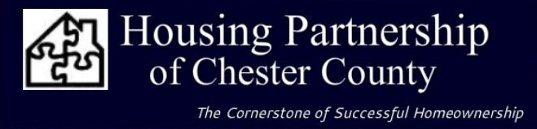

FOR IMMEDIATE RELEASE NAME: Ken Hutton, Executive Director
ken@housingpartnershipcc.com; 610-518-1522 x103

Foxwynd Foundation awards Grant to Housing partnership

March 17, 2023 (Downingtown, PA) The recently formed Foxwynd Foundation honored the Housing Partnership of Chester County by awarding their first grant to support its Housing Stability Programs benefiting Chester County residents. These programs help clients at risk of displacement stay in their homes by addressing immediate safety, mobility, and zoning concerns, as well as providing emergency diversion interventions. Beneficiaries live throughout the county and are income qualified.

Specifically, this grant of $50,000 from the Foxwynd Foundation will directly result in any number of favorable outcomes for low-to-moderate income residents:
- Allow senior citizens to age in place because of residential repairs and modifications made;
- Assist physically-challenge homeowners to address mobility needs;
- Support emergency and critical repairs to homes suffering structural damage or heating, electrical, and plumbing issues; and
- Keep residents struggling to pay for heating fuel during the winter months.

The prohibitive cost of updating homes causes displacement, demolition, and blight, which destabilizes families and can lead to a broader set of issues in neighborhoods. According to a recent poll of Pennsylvania voters from Data for Progress, half of respondents said they would struggle to afford a critical repair, and a quarter have outstanding critical repairs because they cannot pay for them. Additionally, more than a third of the Commonwealth’s low-income residents who apply are turned away from critical state and utility funded energy efficiency programs due to health and safety issues needing to be addressed at their home before efficiency work can be done, according to the Keystone Energy Efficiency Alliance. With this generous funding assistance from the Foxwynd Foundation DAF, the Foxwynd Foundation has provided significate financial resources to the Housing Partnership to break that cycle.

Contact Ken Hutton, Executive Director, at 610-518-1522 ext. 103 or ken@housingpartnershipcc.com to learn more about HPCC’s programs. Contact Pam Villagra, Executive Director at Foxwynd Foundation; P: 484.750.5468; EM: pvillagra@foxwyndfoundation.org.

The Housing Partnership of Chester County is a 501 (c)(3) non-profit corporation established in 1988 and headquartered in Downingtown, PA. Its mission is to improve the quality of life for low-to-moderate income people of Chester County by providing the tools to secure and maintain decent affordable housing. Over the past 35 years, HPCC has coordinated over 480 first-time homebuyers’ settlements, representing more than $3 million in financial assistance, and completed over $5.6 million in repairs for homeowners in Chester County. HPCC also provides free financial literacy programs for all ages.

#

